PaNOSC

Photon and Neutron Open Science Cloud

H2020-INFRAEOSC-04-2018

Grant Agreement Number: 823852



Milestone: MS8 - Implementation of PaNOSC DP framework

Project Deliverable Information Sheet

|  |  |
| --- | --- |
| Project Reference No. | 823852 |
| Project acronym: | PaNOSC |
| Project full name: | Photon and Neutron Open Science Cloud |
| H2020 Call: | INFRAEOSC-04-2018 |
| Project Coordinator | Andy Götz (andy.gotz@esrf.fr) |
| Coordinating Organization: | ESRF |
| Project Website: | www.panosc.eu |
| Deliverable No: | MS8 |
| Deliverable Type: | Milestone |
| Dissemination Level | Public |
| Contractual Delivery Date: | 01/11/2021 |
| Actual Delivery Date: | 12/12/2021 |
| EC project Officer: | Flavius Pana |

Document Control Sheet

|  |  |
| --- | --- |
| Document | Title: Implementation of PaNOSC DP framework |
| Version: 1.0 |
| Available at: https://drive.google.com/file/d/1UVA810yReYjx-jw8cS5Z_DW3DWlCk1tX/view?usp=sharing |
| Files: 1 |
| Date | 15/12/2021 |
| Authorship | Written by: A. Götz (ESRF) |
| Contributors: |
| Reviewed by: J.Bodera Sempere (ESRF) |
| Approved: J.Bodera Sempere (ESRF) |

List of participants

|  |  |  |
| --- | --- | --- |
| Participant No. | Participant organisation name | Country |
| 1 | European Synchrotron Radiation Facility (ESRF) | France |
| 2 | Institut Laue-Langevin (ILL) | France |
| 3 | European XFEL (EuXFEL) | Germany |
| 4 | The European Spallation Source (ESS) | Sweden |
| 5 | Extreme Light Infrastructure Delivery Consortium (ELI-DC) | Belgium |
| 6 | Central European Research Infrastructure Consortium (CERIC-ERIC) | Italy |
| 7 | EGI Foundation (EGI.eu) | The Netherlands |

# Implementation of PaNOSC data policy framework

In May 2020 the PaNOSC data policy framework was delivered to the European Commission as a deliverable of the PaNOSC project. It was published on [zenodo](https://doi.org/10.5281/zenodo.3738497) (DOI 10.5281/zenodo.3826040) and is also accessible via the [PaNOSC website](https://www.panosc.eu/data/panosc-data-policy-framework/). Now, after three years from the beginning of the project, this milestone summarises the situation concerning the implementation of the data policy and that the main features of DP are implemented in the workflow of User access and data production up until publication of DOIs. The publication of DOIs is the indicator that the metadata and data will be archived for the long term accessible via a DOI.

The following table lists the DOI prefix, number of DOIs minted so far and the data repository.

|  |  |  |  |
| --- | --- | --- | --- |
| Facility | Data repository | DOI prefix | # DOIs |
| CERIC-ERIC | <https://vuo.elettra.eu/pls/vuo/open_access_data_portal.show_search> | doi.org/10.34967 | 1 |
| ELI | WIP | WIP | 0 |
| ESRF | <https://data.esrf.fr> | doi.org/10.15151 | 1434 |
| ESS | <https://scicat.ess.eu> | doi.org/10.17199 | 471 |
| EuXFEL | <https://in.xfel.eu/metadata> | doi.org/10.22003 | 25 |
| ILL | <https://data.ill.eu> | doi.org/10.5291 | 5835 |

# Example DOI landing pages

This section contains examples of DOI landing pages for each facility

## CERIC-ERIC - <https://doi.org/10.34967/i8163>

## 

## ESRF - <https://doi.org/10.15151/esrf-es-436275363>

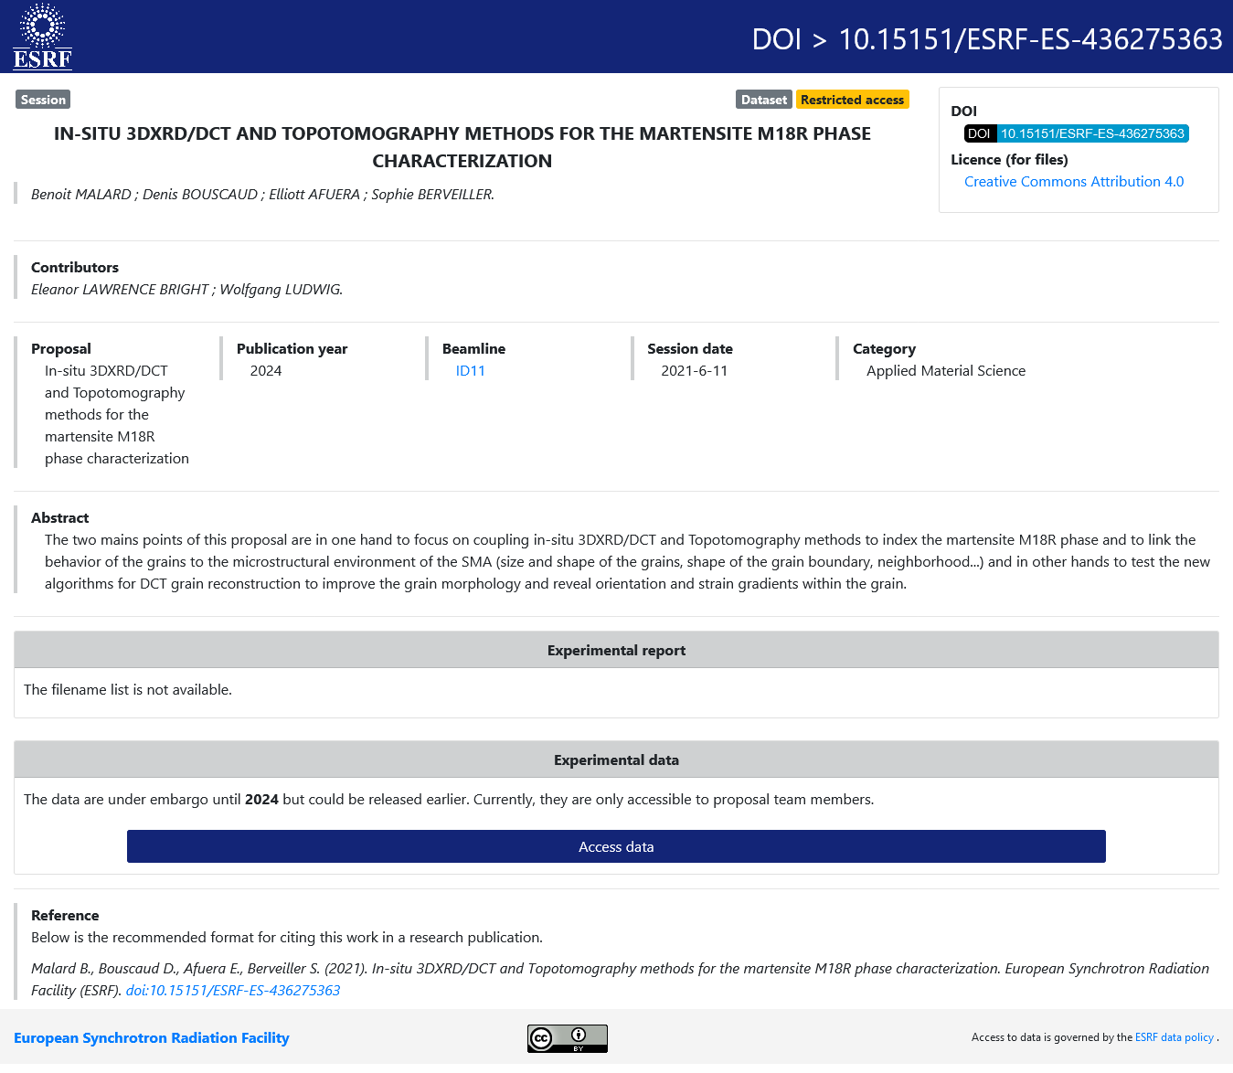

## 

## ESS - <https://doi.org/10.17199/brightness/beaminstrumentation0002>

## 

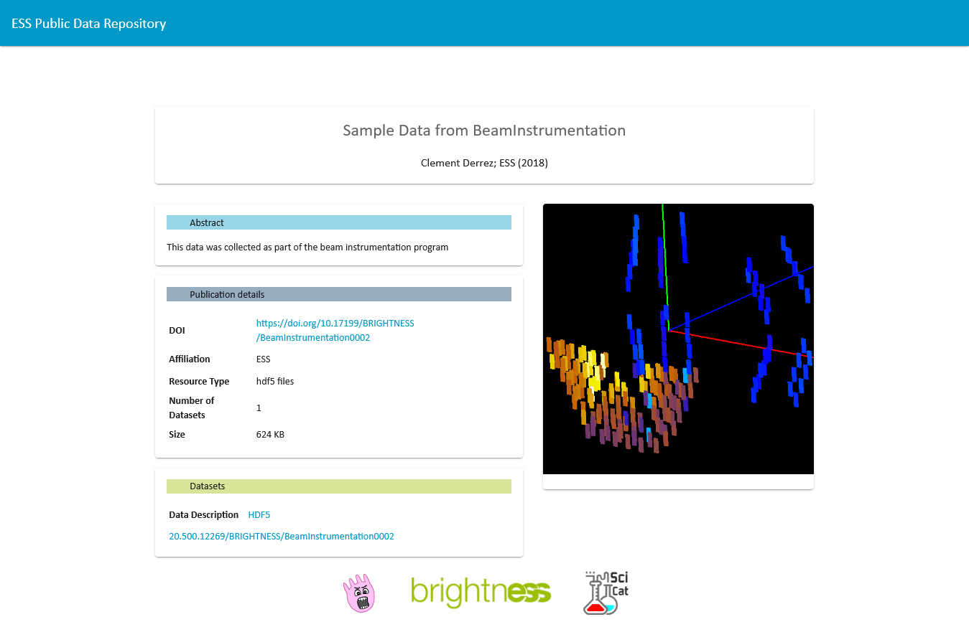

## 

## EUXFEL - <https://doi.org/10.22003/xfel.eu-data-002038-00>

## 

## 

## ILL - <https://doi.org/10.5291/ill-data.9-11-1626>

## 

## 